Term Time Dates
Academic Year 2023/2024
School Opens School Closes

Autumn Term
Monday 4th September 2023 Friday 20th October 2023
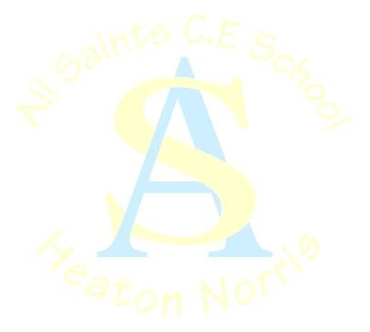
(Please note Monday 4th is an INSET day school will open for children on Tuesday 5th September, Friday 20th October is an INSET day)
Monday 30th October 2023 Friday 22nd December 2023
(Please note Friday 22nd December is an INSET day)

Spring Term
Monday 8th January 2024 Friday 9th February 2024
Monday 19th February 2024 Thursday 28th March 2024

Summer Term
Monday 15th April 2024 Friday 24th May 2024
Monday 10th June 2024 Friday 26th July 2024
INSET days
Monday 4th September 2023
Friday 20th October 2023
Friday 22nd December 2023
Monday 29th July 2024
Tuesday 30th July 2024
Public Holidays (school closed)
May Day - Monday, 6th May 2024
Other Important Dates
SATs: week May 2024 TBC

