

**All Saints Newsletter**

**Friday 26th January 2024**

**Head Teachers Comments**

This week I have had the pleasure of teaching Year 6 for a Maths lesson. I had a wonderful time in the class, and they are certainly confident with their mathematics skills and knowledge. Over the coming weeks I will be going into each class to teach the children to get to know them more.

I am hearing good reports from Mrs Seth on how well Y5 are progressing at swimming, which is a key life skill. I am sure over the coming weeks they will become even more confident in the water and develop their swimming skills.

A polite reminder that the safety of our children is paramount and access to the school gates is vital. Please could parents avoid parking here in the morning and evening.

Have a lovely weekend with family and friends see you all on Monday. It will be an actioned packed week with Year 4’s class assembly and the week ending with NSPCC Number Day, which Mrs Seth has sent out information about earlier this week.

Mr Longworth

***Half term root value – Love***

**Year 1 special visitors…**

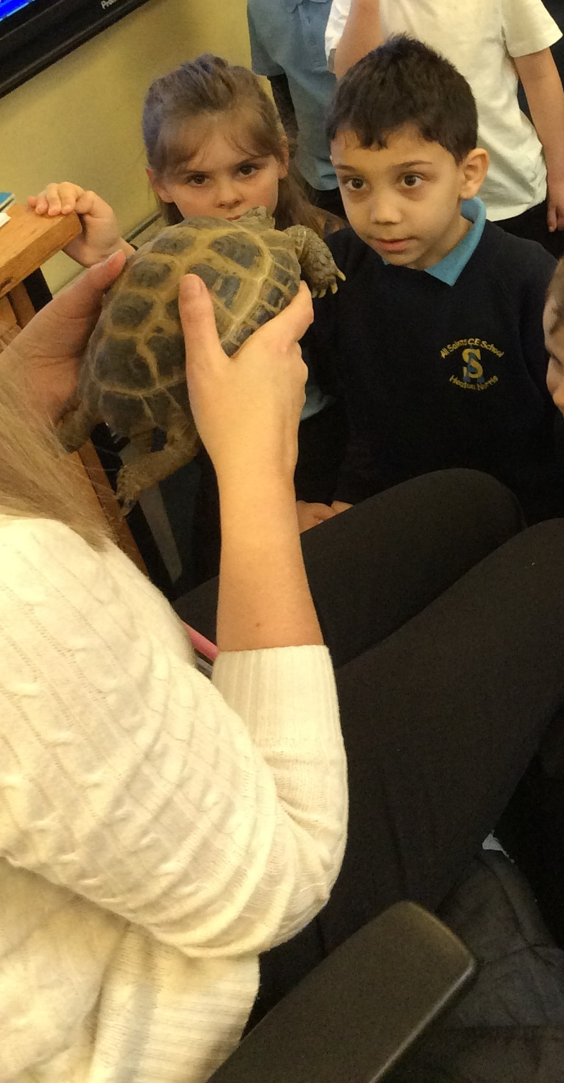

Children in Year 1 are learning about Hot and Cold Countries. On Thursday, the class had two special visitors… ‘Sheldon’ the tortoise and ‘CurlyWurly’ the snake. Children had a lovely time with the animals and learnt lots!

**Dates for your diary…**

Thursday 1st February – Y4 Class Assembly

Friday 2nd February – NSPCC Number Day

Tuesday 6th February – Y3 Roman Workshop

Wednesday 7th February – Y4/Y5 Trip to Manchester Museum

Friday 9th February – Break Up for Half Term

**PTA News…**

You will have all received a letter from the PTA today regarding a ‘Love’ competition. They are asking children to write on the heart template what they love about All Saints. Entries are 50p and need to be handed in to their class teacher by Thursday 8th February. Winners will be announced in the celebration assembly on Friday 9th February. Good luck to all and I look forward to reading and seeing your pictures of what you love about school. Be Creative!



***Stars of the Week***

**Reception: Wesley and Dexter**

**Year 1: Yousif and Piper**

**Year 2: James and Thomas**

**Year 3: Myles and Luca**

**Year 4: Taylor and Bruce**

**Year 5: Adam and Dzheyda**

**Year 6: Riley and Bobby**

**1st Place: Year 1 97.1%**

**2nd Place: Year 2 96.6%**

**3rd Place: Year 6 96.1%**

**Reception 95.6%**

**Year 4 95.2%**

**Year 3 92.2%**

**Year 5 86.5%**

**Attendance Winners**

Whole School Attendance 93.3 % (Target 96%)

**“Where we learn to value Knowledge;**

**To value each other;**

**But most of all…to value ourselves”**