

**All Saints Newsletter**

**Friday 9th February 2024**

**Head Teachers Comments**

A huge thank you to everyone: children, staff, governors and parents for making me feel so welcome. I have thoroughly enjoyed my first half term at such a friendly and fantastic school. We have begun our journey and as a community, we can grow and flourish further together. I am looking forward to sharing schools new mission statement, vision and values with you soon, having collated feedback from staff, parents and children.

**NSPCC number day raised £731.34** – a huge thank you to everyone in raising a great amount of money. Times Table Rock Star winning classes were Year 5 and 6. All classes made a fantastic effort and were close to the winners. The three winning pupils scores from TTRS were Riley (Y5) 4048 points, Zhuowen (Y6) 2564 points and Pearl (Y5) 2029 points. Well done to all children who gave it their all last Friday.

I hope you all have a lovely half term with family and friends and cannot wait to hear about what fun you have had.

Mr Longworth

***Half term root value – Love***

**Y3 Roman Workshop…**

Year 3 arrived dressed in their fantastic outfits ready for Roman day. They met Mad, the Roman soldier, who took them through the history of the Roman Empire. Their day was filled with exciting, educational activities: an interactive quiz, real Roman board games, chariot racing, learning how to march in a Roman cohort on the way to battle, trying on authentic Roman armour, learning how the Romans fought with weapons and holding real Roman artefacts - a Roman oil lamp and a toilet brush!

**Dates for your diary…**

Tuesday 27th February – Parents Coffee Morning 9am

Thursday 29th February – Y1 Florence Nightingale Workshop

Thursday 29th February – Y2 Queen Victoria Workshop

Thursday 14th March – Y2 Class Assembly

Monday 25th March – Parents Evening

**Y4/5 Trip to Manchester Museum…**

Year 4 and year 5 had a fabulous time at The Manchester Museum, where they had the opportunity to explore a plethora of cultures from the Ancient Egyptians and Sudan, to celebrating China and South Asia.

During the visit, children sketched and recorded facts on animals from around the globe, both living and extinct. The classes had the chance to speak to real life herpetologists focusing on conserving rare and endangered reptiles and amphibians within the museum.

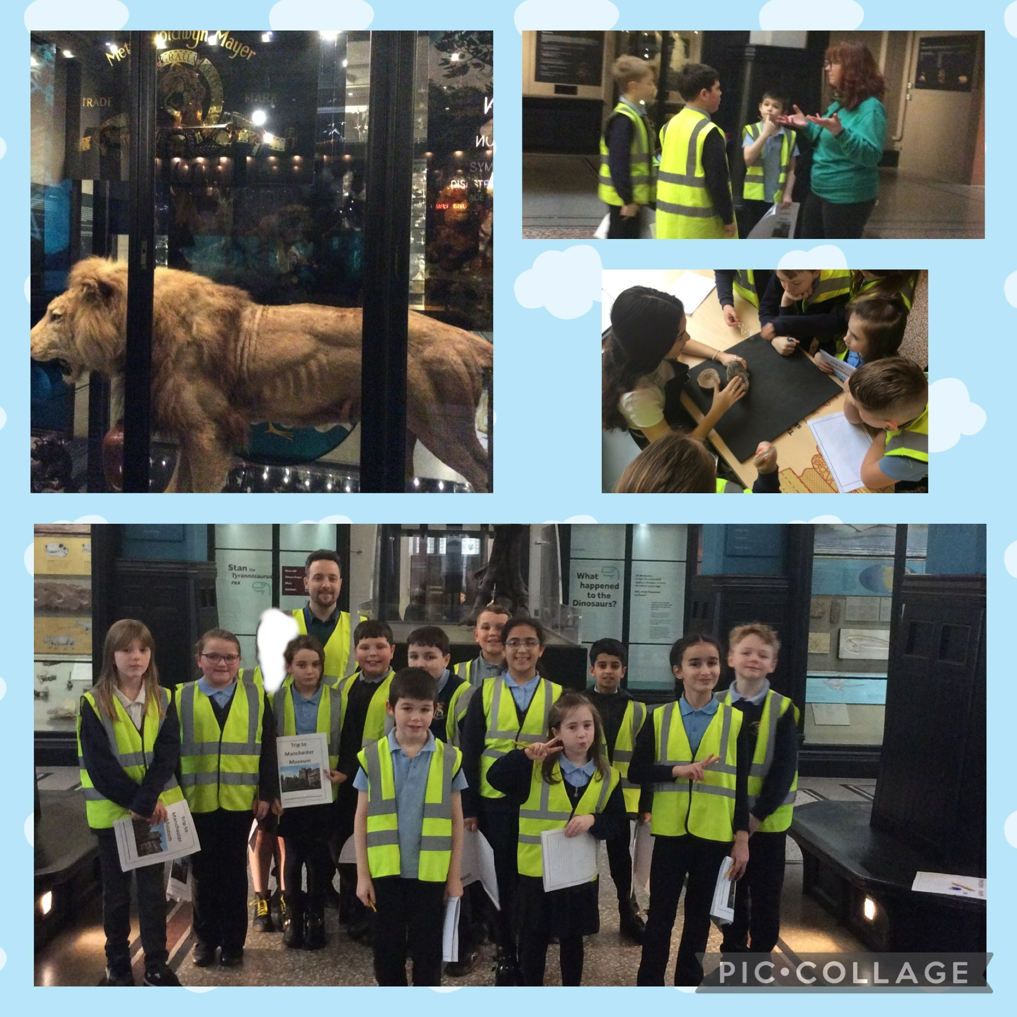

***Stars of the Week***

**Reception: Elliott & Jasper**

**Year 1: Pippa & Ava**

**Year 2: Daisy & Darcie**

**Year 3: Luna & Hasnain**

**Year 4: Jack & Mya**

**Year 5: Max-Jacob & Tia**

**Year 6: Thomas & Harris**

**1st Place: Year 2 97.6%**

**2nd Place: Year 5 97.3%**

**3rd Place: Year 3 96.3%**

**Year 1 93.7%**

**Year 6 93.6%**

**Reception 93.2%**

**Year 4 93.1%**

**Attendance Winners**

Whole School Attendance 95.2 % (Target 96%)

**“Where we learn to value Knowledge;**

**To value each other;**

**But most of all…to value ourselves”**