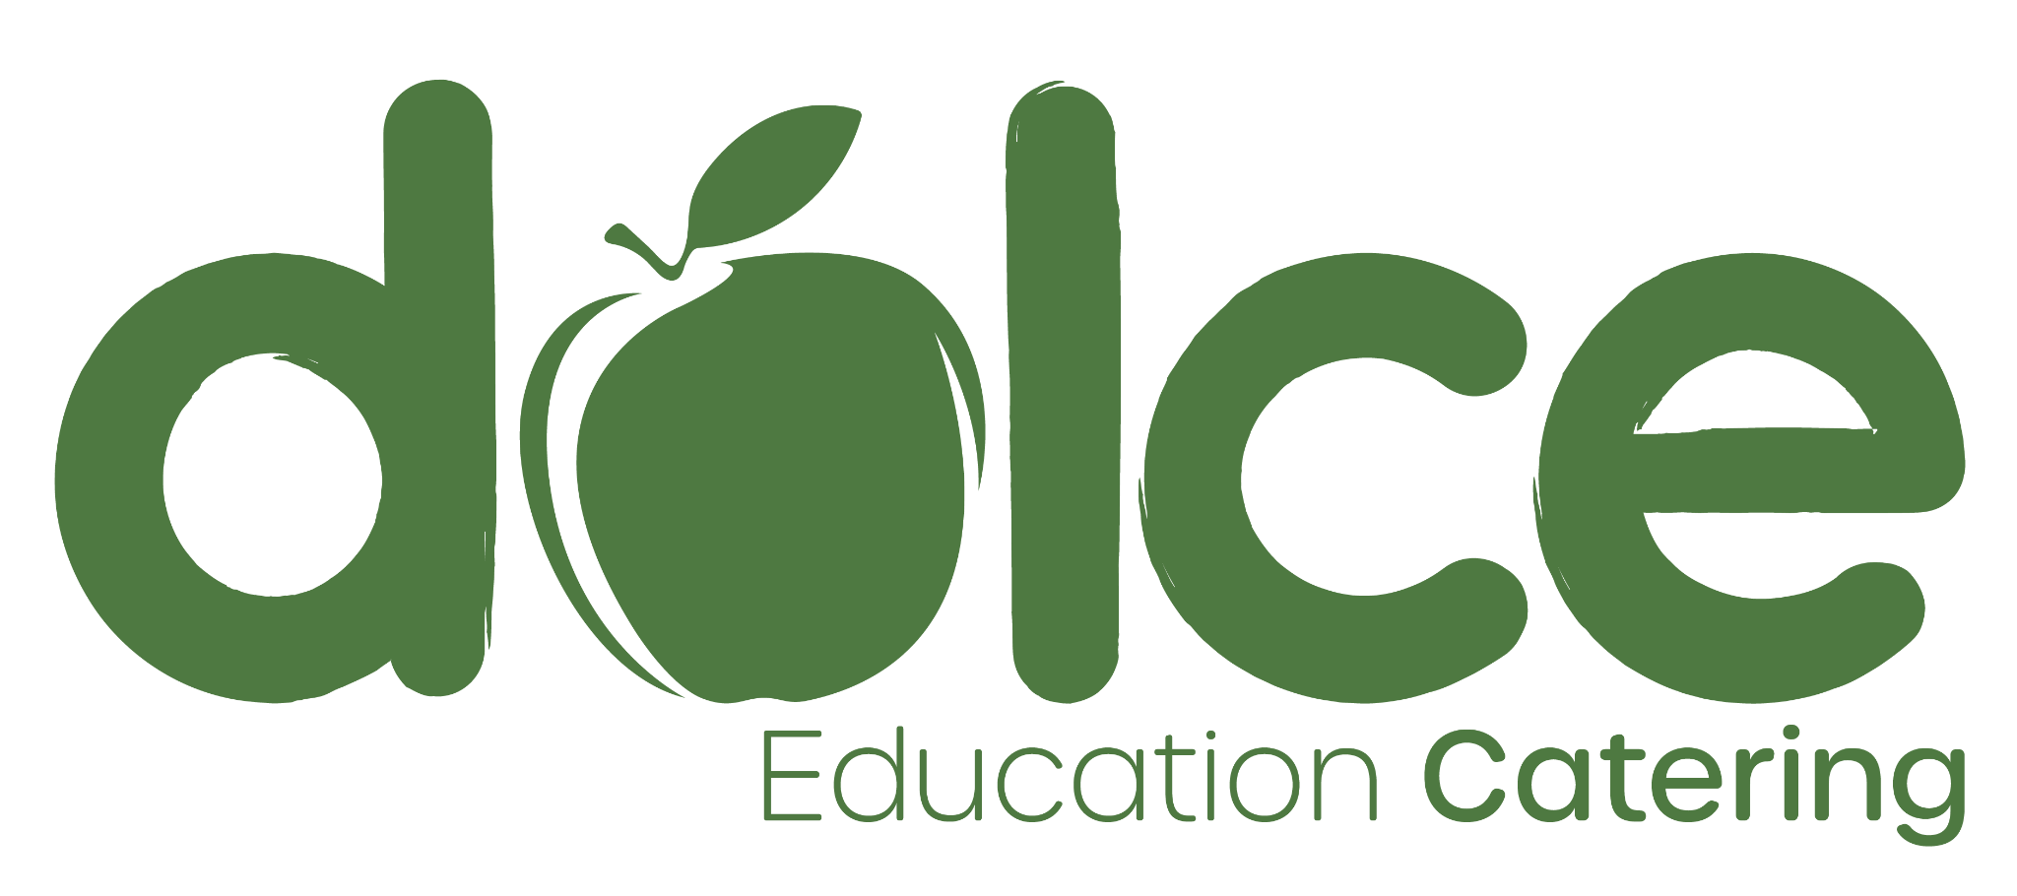
1st March 2024
Dear Parent / Carer,
April Meal Price Increase
We hope your child or children are enjoying our school lunches. We strive to provide a range of daily options that remain popular, nutritious and produced from ethically sourced raw ingredients that require a good standard of craft skill to prepare.
However, the issue that all caterers are currently facing, is a significant increase in food inflation (for various reasons) and wage inflation, as dictated by an increase in the national living wage.
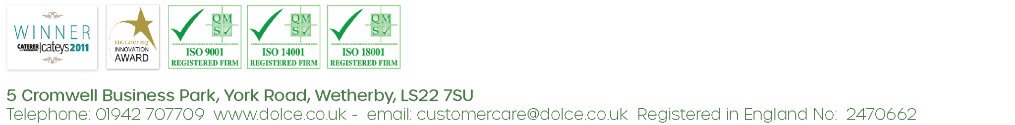
The increases of 9.8% on our staffing costs from April 2024 and up to 19% on food costs needs to be reflected, at least in part, in our charges to you. We will continue to try and mitigate these additional costs by driving efficiencies within our organisation, however, as a result, we will reluctantly need to reflect them in our charges from the start of the summer term.
Your school meal price from 1st April 2024 will be:
£2.73 (For children in Key Stage 2)
£2.42 (For children in Nursery)
Benefit-Related Free School Meal children and Universal Free School Meal children (Reception, Year 1 and Year 2) remain free.
If you have any further questions or concerns please do not hesitate to contact Customer
Care on 01942 707709 / customercare@dolce.co.uk
Kind Regards,
Angie Lingwood
Head of Dolce Customer Care

