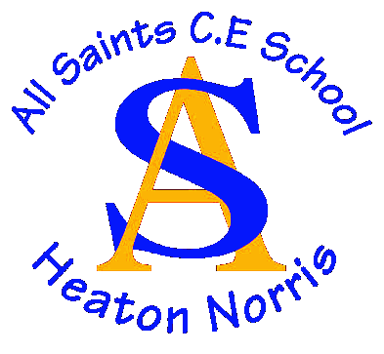

All Saints CE Primary School

PRIVACY NOTICE – TELEPHONE AND CCTV RECORDINGS

Version | Author | Policy approved by | Approval date | Review date | Changes made
V1 | Information Governance Team | Information Governance Team |  |  | New

How we use telephone and CCTV recordings:

All Saints CE Primary School is committed to ensuring that we are transparent about the ways in which we use your personal information and that we have the right controls in place to ensure it is used responsibly and is kept safe from inappropriate access, theft or misuse. All Saints CE Primary School is a ‘data controller’ for the purposes of the (UK) General Data Protection Regulation (GDPR).
This privacy notice explains how we use your personal information and tells you about your privacy rights and how the law protects you.
We collect your information to:
Telephone call recording:
- For training purposes
- Maintain a safe environment
- Ensure the welfare of staff
- Maintain the highest level of safeguarding for children & staff

CCTV
- Maintain a safe environment.
- Ensure the welfare of pupils, staff and visitors.
- Deter criminal acts against persons and property.
- The prevention, investigation and detection of crime.
- Monitoring the security of the site.

The categories of this information that we collect, process, hold and share include:
Telephone Calls recordings
- Telephone Calls recordings
- Telephone numbers unless the number is withheld by the caller.
CCTV
- Images and video footage of pupils, staff, parents and visitors

The lawful basis on which we use this information:
Legitimate Interest:
The school has a legitimate interest in recording telephone conversations, unless those interests are overridden by you by asking for your call not to be recorded. Call recordings will be used:

Public Task;
We process CCTV data in order to comply with our public task, namely to ensure that the security of our pupils, staff, buildings and their contents are maintained at all times.
Collecting this information
Telephone Calls recordings
All calls to and from the school may be recorded. Individuals will be informed that the call is being recorded before the call takes place.

CCTV

In areas where CCTV is used the school will ensure that there are prominent signs in place.
The signs will be:

- Clearly visible and readable.
- An appropriate size depending on context.

Storing this information

Recorded images and calls will be stored in a way that ensures the integrity of the recording and in a way that allows specific times and dates to be identified. Access to recordings is restricted to the Headteacher and School Business Manager.
Who we share data with;

We use third party suppliers for our phone and CCTV systems.

We do not routinely share this information with any external organisations or third parties.

There may be circumstances in which we may lawfully share CCTV images or telephone recordings with third parties where, for example, we are required to do so by law, by court order, or to prevent fraud or other crimes. Where we share data, however, we shall do so in accordance with applicable data protection laws.

We will not give information about you to anyone outside this establishment without your consent unless the law permits it.
Data Retention
The data will be retained for 6 months after which time it will be destroyed.

However, on occasions there may be a need to keep recordings for longer, for example when further investigation is required into the matter being raised or where there has been behaviour that is abusive, offensive, threatening or has caused distress or alarm to the school or its employees.

Rights of individuals
You may exercise the rights listed below in relation to our use of your personal information. Some rights are absolute and others are not.
To find out more about how these rights apply in particular circumstances, please refer to our https://www.allsaints.stockport.sch.uk/page/policies
To exercise these rights, please contact Ms T Cartmill – School Business Manager by emailing theresa.cartmill@allsaints.stockport.sch.uk

Complaints (ICO)
If you are not satisfied with the way we have answered a request from you or handled your personal information, you have the right to make a complaint to the Information Commissioner.
Information Commissioner’s Office
Wycliffe House
Water Lane
Wilmslow
Cheshire
SK9 5AF

Email: casework@ico.org.uk

This right is not dependant on you raising a complaint with us first, but we would encourage you to contact our Data Protection Officer by emailing IGSchoolSupport@stockport.gov.uk so we can consider your concerns as quickly as possible.

Keep updated on changes to our privacy notice
We may update or revise this privacy notice at any time so please refer to the version published on our website for the most up to date details.

